H.T No
Regulations:
A18

Sreenidhi Institute of Science and Technology
(An Autonomous Institution)
Code No: 7A201 Date: 02-Nov-2021 (AN)

B.Tech I-Year II- Semester External Examination, Oct/Nov-2021 (Supplementary)
ELECTRICAL CIRCUITS AND NETWORKS-I (EEE)

Time: 3 Hours Max.Marks:70

Note: a) No additional answer sheets will be provided.
b) All sub-parts of a question must be answered at one place only, otherwise it will not be valued.
c) Missing data can be assumed suitably.

ANSWER ANY 5 OUT OF 8 QUESTIONS. EACH QUESTION CARRIES 14 MARKS.

Bloom's Cognitive Levels of Learning (BCLL)

Remember | L1 | Apply | L3 | Evaluate | L5
Understand | L2 | Analyze | L4 | Create | L6

 |  |  | BCLL | CO(s) | Marks
1. | a) | Consider the following example to prove the current through a resistor 5Ω is unchanged before and after source transformation.  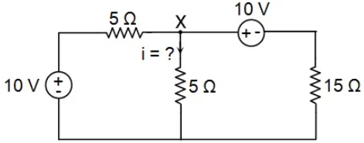 | L3 | CO1 | [7M]
 | b) | The voltage waveform shown in Figure 1 is applied to a pure capacitor of 40μF. Sketch i(t) and p(t) and Determine I_{max} and P_{max}.  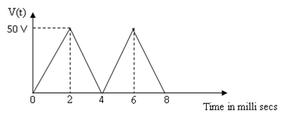 | L2 | CO1 | [7M]
2. | a) | What is Duality? Explain procedure for obtaining dual for the planar network. consider an example with 5 nodes. | L1 | CO2 | [7M]
 | b) | Draw and explain basic cut-set, tie-set matrices by considering a planar network. | L6 | CO2 | [7M]
3. | a) | (i) Derive an expression for a relation between self and mutual inductance (ii) Two similar coils connected in series give a total inductance of 600 mH and when one of the coils is reverse, the total inductance is 300 mH. Determine mutual inductance and coefficient of coupling. | L5 | CO3 | [7M]
 | b) | Bring out the analogy between Magnetic and electric circuits | L4 | CO3 | [7M]
4. | a) | In a series R-L circuit, the current and voltage are given by i(t)= cos (314t-20⁰) V₁(t)=10 cos(314t+10⁰ ) Find the values of R & L. | L3 | CO4 | [7M]
 | b) | Explain R-C circuit for sinusoidal excitation | L4 | CO4 | [7M]
5. | a) | Elaborate and draw the current locus for series R-L circuit with fixed R and variable L. | L3 | CO5 | [7M]
 | b) | A series circuit consisting of R = 500Ω, L = 0.5H and C = 15μF is connected to a variable frequency supply of 120V. If the frequency is varied through 40 to 80Hz, Draw the locus diagram of current. | L5 | CO5 | [7M]
6. | a) | State and explain Thevenin’s Theorem, Use super position theorem to find the current through 2 Ω for the following circuit .  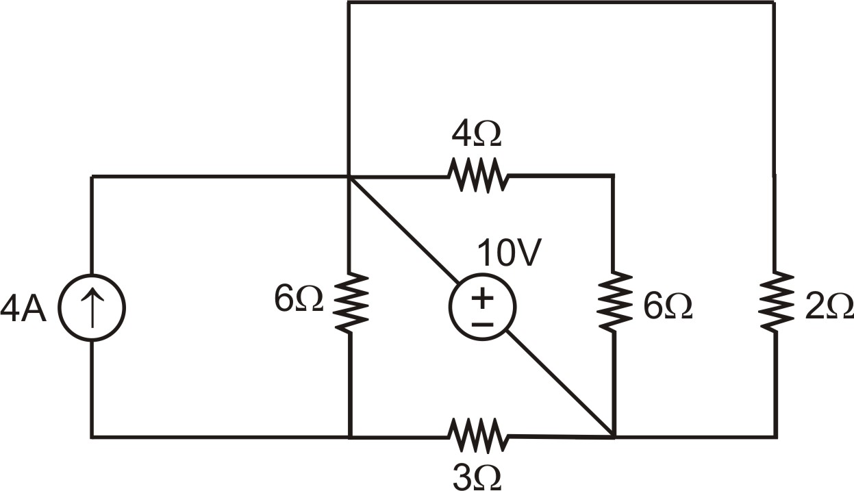 | L4 | CO6 | [7M]
 | b) | Find the value of ZL to be connected between the terminals AB of the circuit shown in figure, for maximum power transfer. Find maximum power.  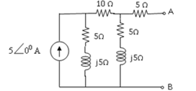 | L5 | CO6 | [7M]
7. | a) | 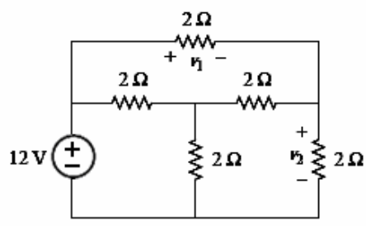  Use Mesh analysis to find current through and voltage across each branch of the circuit shown below. | L3 | CO1 | [7M]
 | b) | Derive expressions for converting star-delta, vice versa transformations | L2 | CO2 | [7M]
8. | a) | Explain the following each with an example  (i)Tie-set (ii) Graph (iii)incidence Matrix (iv)link (v)Duality in electric circuit | L1 | CO4 | [7M]
 | b) | Draw the dual network for the following circuit.  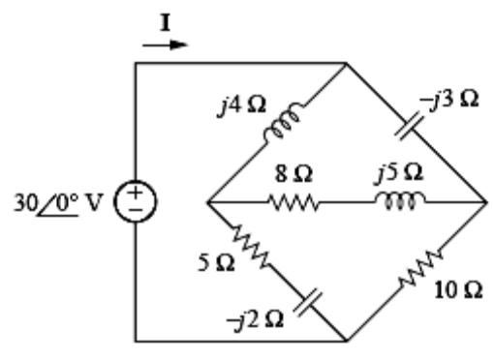 | L3 | CO5 | [7M]

-- 00 -- 00 –

